**ANNUAL REPORT  2020-21**

**TABLE OF CONTENTS :-**

* Metamorphosis
* Startup Sunday
* Ideoclash
* Trailblaze
* Rakshapreneur
* Case study
* Pitchers
* Big bull

**.       METAMORPHOSIS**

Metamorphosis, conducted by E- Cell NIT-B, is an annual tradition on campus that will be held during NIT-B’s technical fest Technosearch on 20th october 2019. Every year amazing panelists show up to guide and inspire young minds, shaping them into future entrepreneurs.

As the orators were the alumni of NIT-B, Metamorphosis was a momentous event. Mr.Yashraj Sunhare and Mr.Shubham Kumar, CEO and CTO of Jarvis Labs- a drone technology startup, were welcomed as the keynote speakers for this event. They spoke about the work that inspired them and the rattling stories of their college life and their journey at their startup,  resulting in a very fruitful session for the students who were ardent seekers of experienced guidance and needed a kick start for their start-up career.

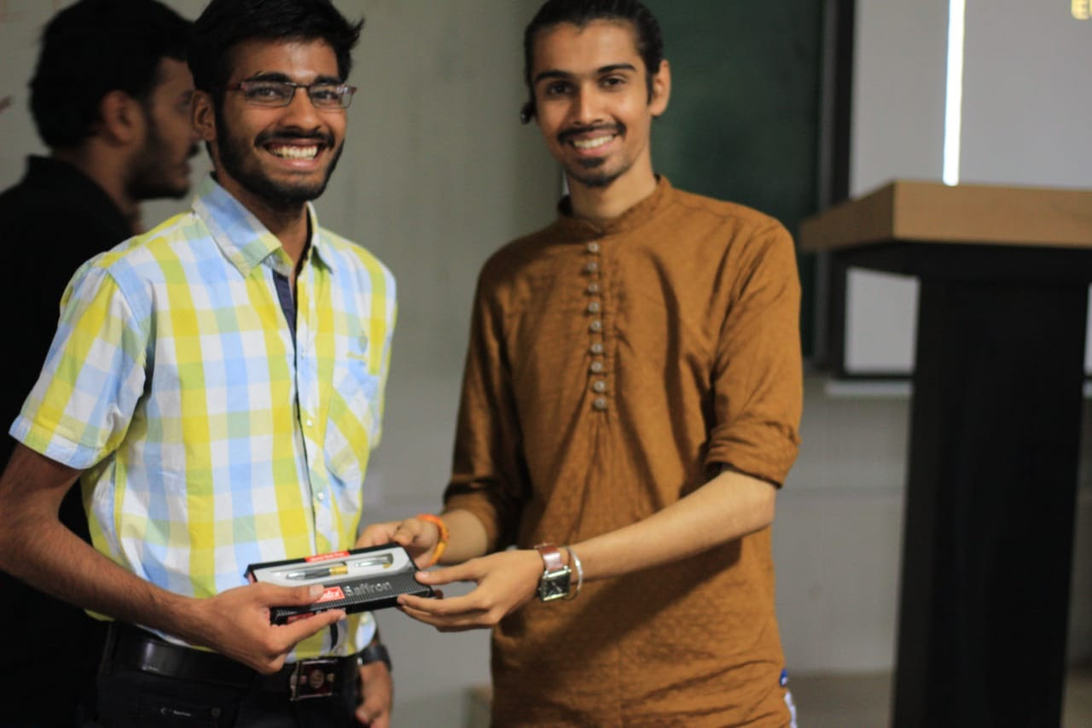

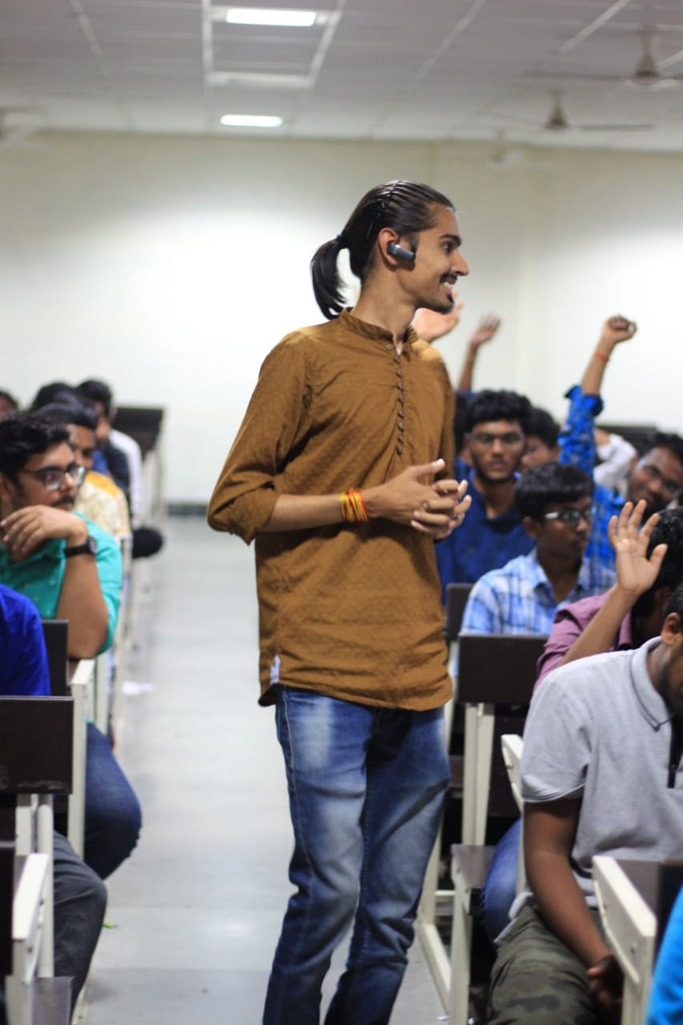

**·       STARTUP SUNDAY**

One of the most impactful events conducted by E-Cell NIT-B was Startup Sunday, marking its footfall of more than 500 students on the 1st of March, 2020. It was a seminar facilitated by Mr. Nemesh Singh, the founder, and CEO of Appointy, a globally established startup helping businesses grow exponentially. He bewitched the audience with his unconventional entrepreneurial journey, where he enlightened them with the success and failures which ultimately paved his startup journey to a multimillion-dollar revenue company. The talk was followed by a brainstorming question-answer session, which lighted up a new streak of ideas among the students, ending in another successful event hosted by us.

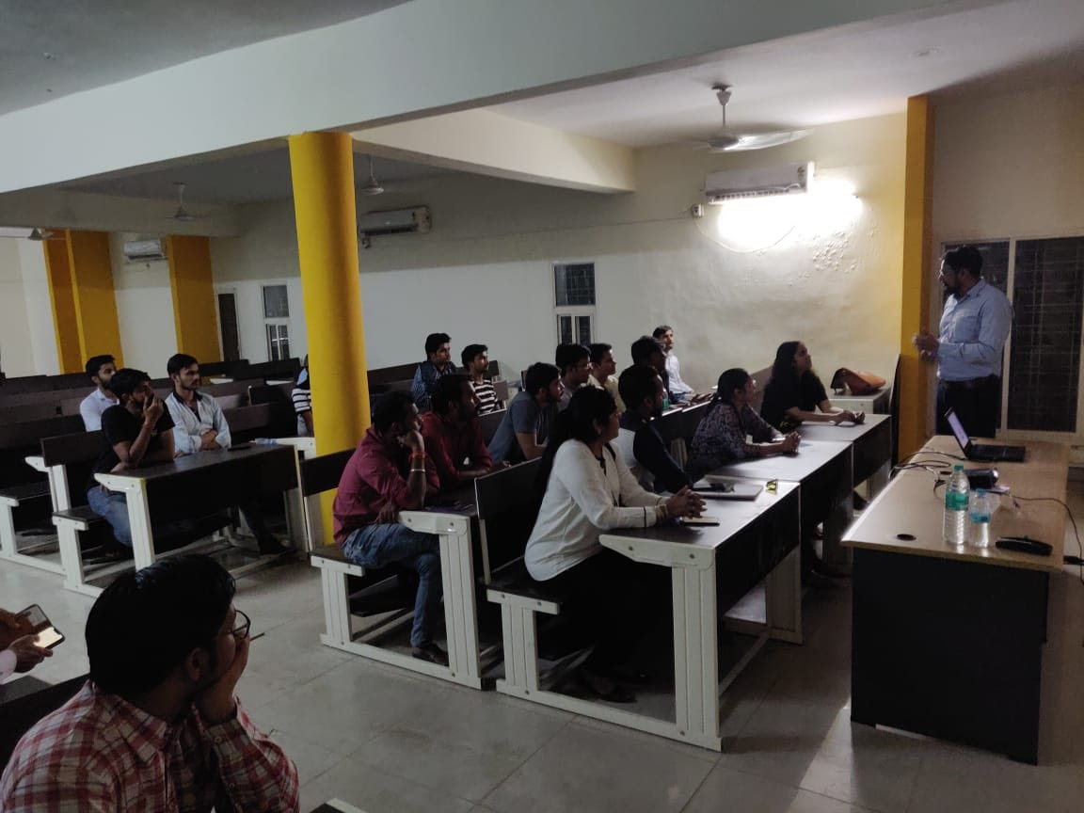

.       **IDEOCLASH**

Every problem has its creative solution. ‘Ideoclash’ is a unique event held on 6th september 2020 that is an opportunity for people to have a curiosity or skill of developing innovative plans for the obstacles encompassing us. The attendees from various colleges across India conferred with affirming feedback.

IdeoClash is a string of two events- Ideation and Seminar. The first episode of IdeoClash was a battle of brainstorming ideas that stand out from others. The fascinating ideas were rewarded with prizes worth thousands.

The second episode of the event focused on imparting the knowledge of experts to all the participants. A pre-eminent panel of entrepreneurs consisting of Mr. Shahrukh Shamim, CEO & Co-Founder of Envicore inc., and Ms. Smriti Tomar, CEO & Founder of Stack Finance was solicited to mentor and elucidate the queries of students on building and scaling an idea. It was an extremely interactive and prolific session that brought the participants another step closer to their dreams.

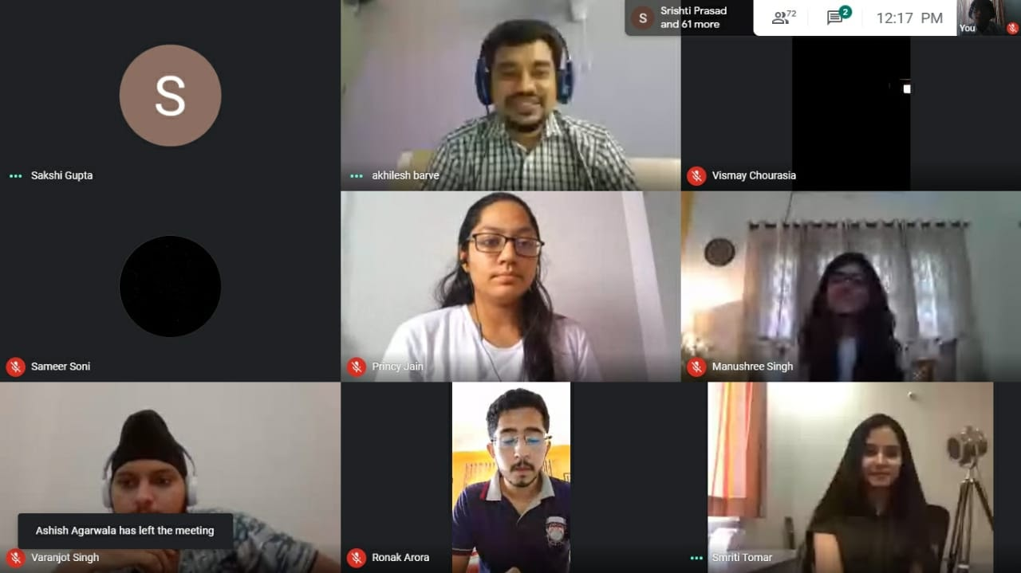

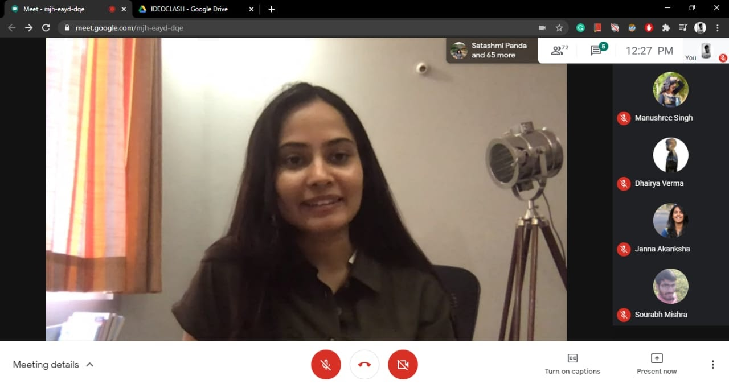

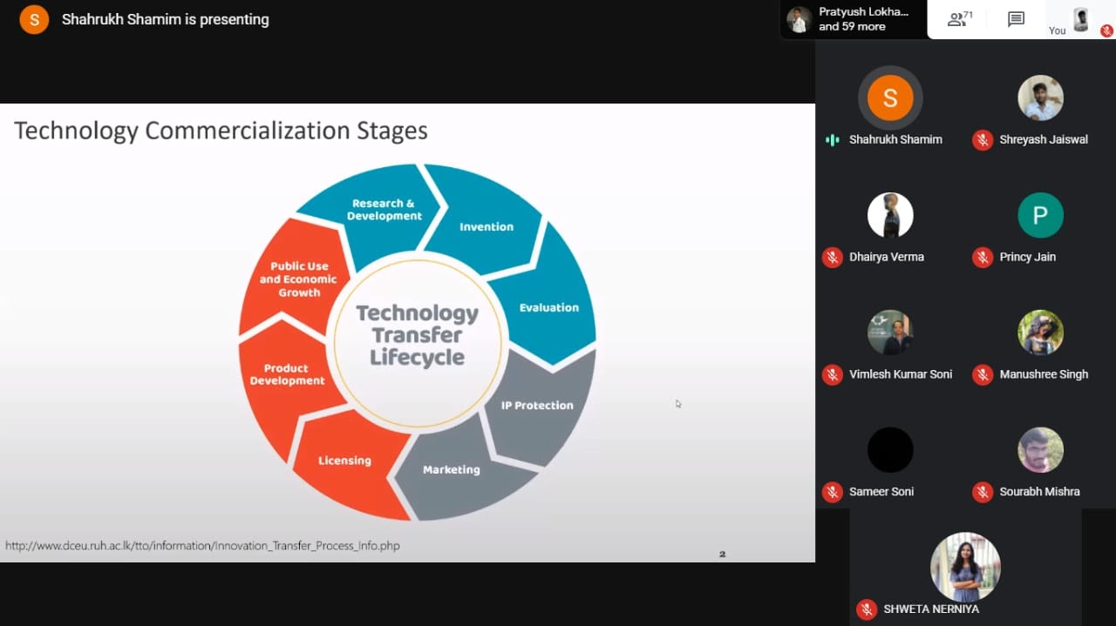

**·       TRAILBLAZE**

E-Cell NIT-B in collaboration with lifeclass.io held an interactive session on 31st october 2020, the speaker being the alumnus of BITS-Pilani, Mr. Vishnu Chundi, Co-founder and CEO of AssetVault. The webinar revolved around the most commonly raised fear, “How not to fail at Startups?”. Mr. Chundi guided students in the areas concerning lean startup methodology, gathering startup funds, choosing a co-founder, and developing a core team. The session was a whole of an entrepreneurial guide, providing the detailed fundamentals of a startup career. Trailblaze was embraced by the participation of about 500 students who were delighted to have him as the speaker.

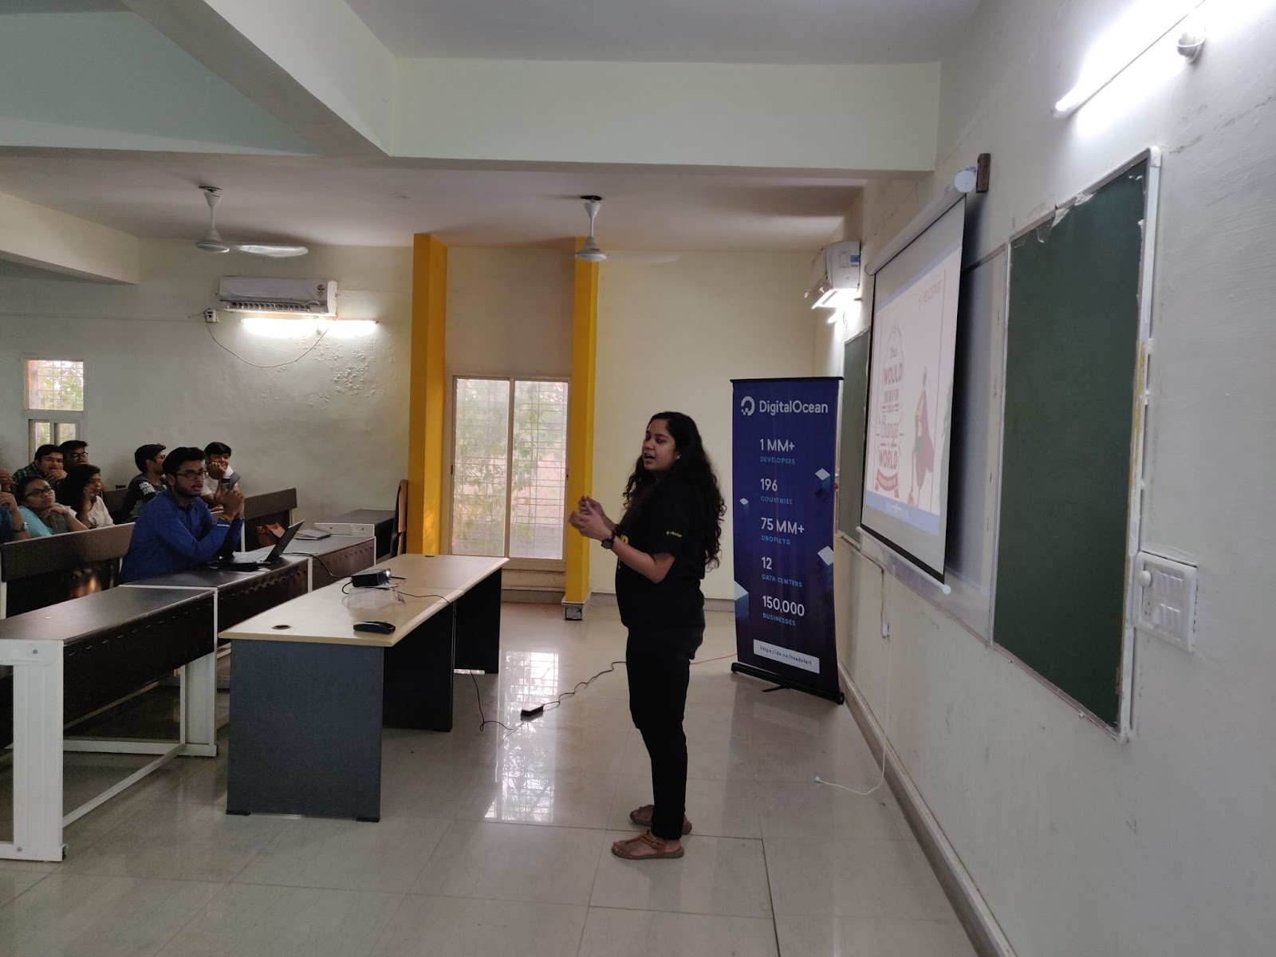

**.         RAKSHAPRENEUR**

This event was graced by **Mr. Major Gen G.D. BAKSHI** on 4th of january 2021.

          He is an author, a former Indian Army officer and a speaker.

A highly sought-after speaker on military and defence, Major General G.D. Bakshi is a retired army officer and writer of over 35 books. He was conferred with the Vishisht Seva Medal for commanding a battalion in the Kargil War and the Seva Medal for commanding a battalion during counter-insurgency drives. The session was quite interactive and about 500 students learned a lot from the session.

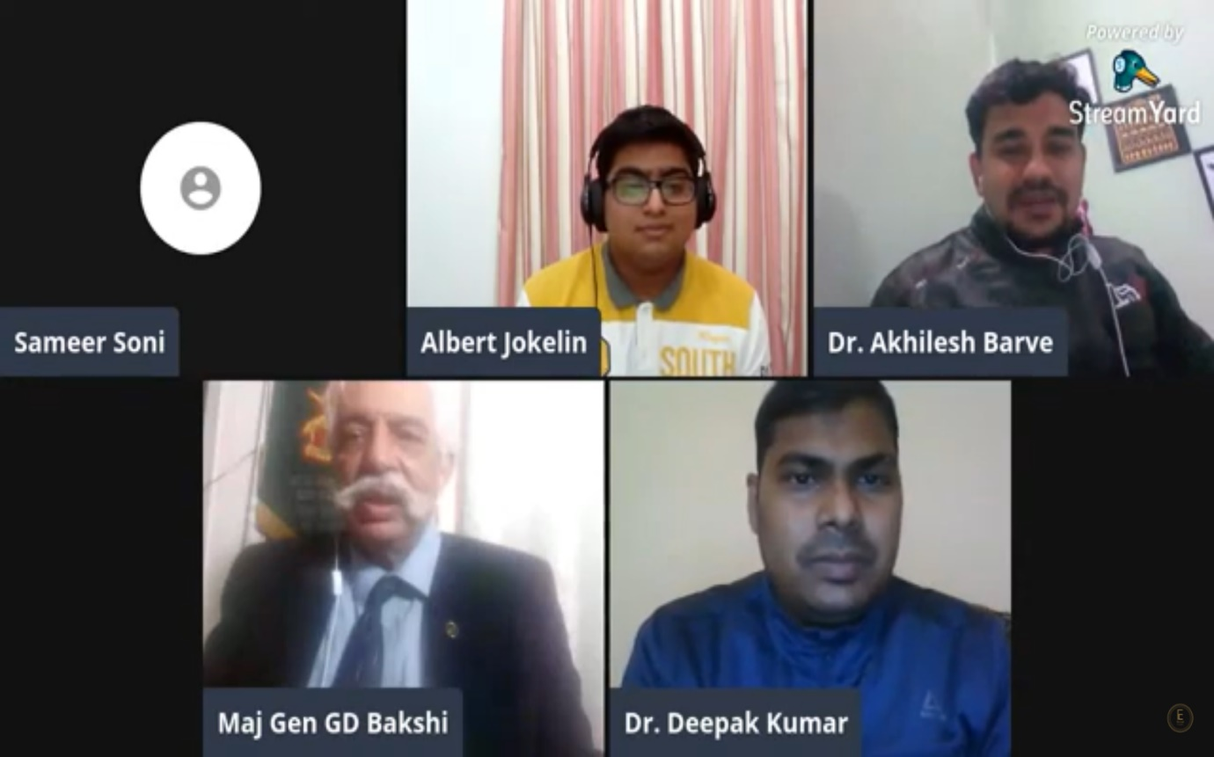

**.**  **CASE STUDY COMPETITION**

The art of research and analysis is one of the most crucial skills required. Case study competition is the most prolific event of E-Summit'21(11th - 21st march) that focuses on the pitching of new business ideas focusing on entrepreneurial abilities. With the stupendous amount of 2500 attendees, the table discussions yielded a vast range of business ideas. The participants were given a mind-boggling statement on problems faced by startups. The competitors must pitch a plan that solves the problems.

The competition proved to be valuable for everyone in gaining knowledge and honing their skills. The initiative of this event was to develop a spirit of teamwork and present their ideas in a compact and precise way.

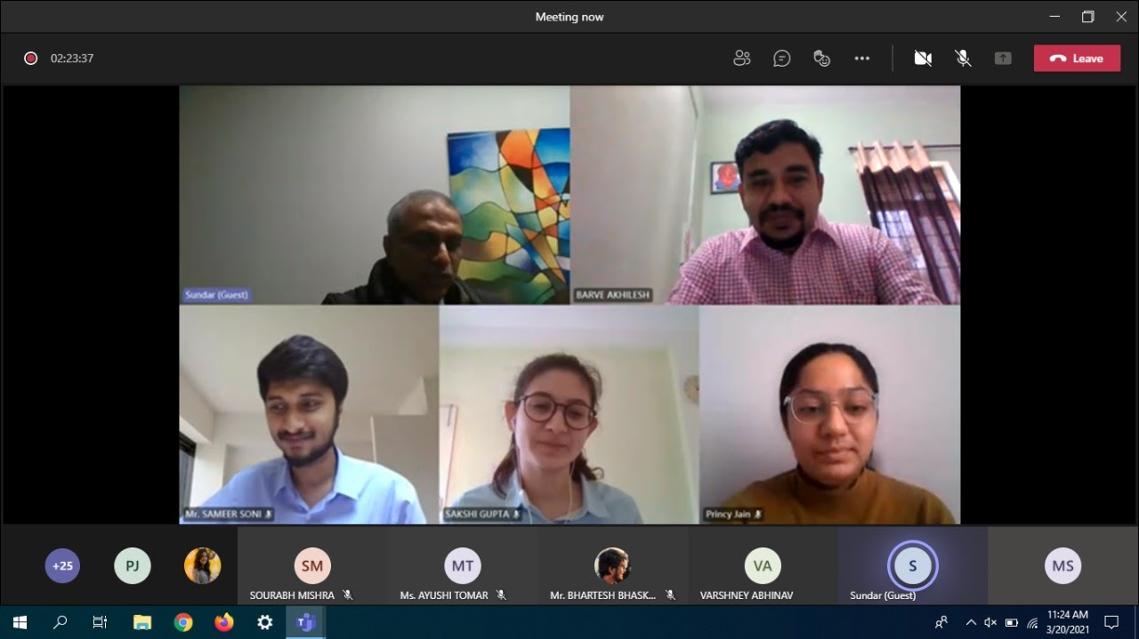

**.       PITCHERS**

Pitchers was one of the most exuberant events organized during E-Summit’21 (13th - 21st March). It clubbed a workshop and a competition, arranged for the students seeking guidance in the field of business plans.

Pitchers Workshop was conducted in the first phase of the event aiming to teach the techniques of making an effective B-Plan, irrefutable for investors. On 13th March 2021, via MS Teams, the event was embraced by Mr. Priyank Ahuja, the product manager, and a consultant at Accenture. The workshop received overwhelming participation from around 2500 students.

The second phase of the event was marked by competition, laid to test one’s skill set, evaluated by the dignitaries: Mr. SUMAN GANDHAM (CEO & Founder of FININ), Mr. SUNDAR PERANGUR (Startup Mentor & Product Innovator), Mr. SHASHANK RANDEV (Founder VC at 100X.VC). 10 teams were selected based on lean canvas and their pitching of ideas in a restricted time frame of 5-8 min. The students learned about different challenges a business could face, and were blessed by fine tips and tricks to overcome them. The winning teams were awarded the trophy, cash prizes, and gift vouchers.

Successfully organized by E-Cell NIT-B, PITCHERS ended with some lively discussions.

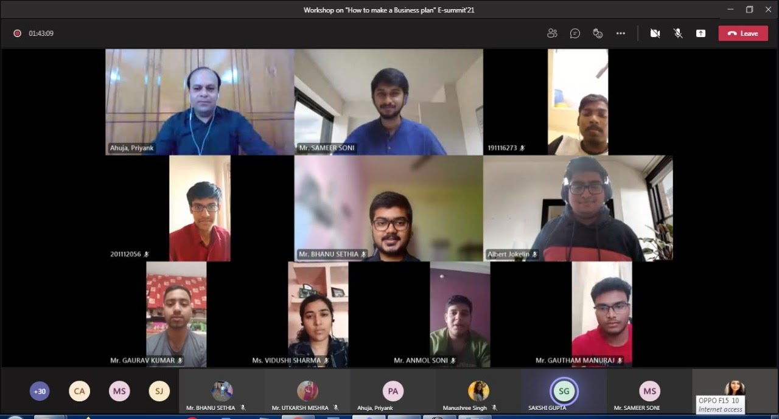

.        **BIG BULL**

As the fad for stock trading grows every day, more competitors increasingly come to the forefront. Big Bull is an event that brings awareness about the world of commerce.

This 5-day event (15th - 19th march 2021) , conducted by Finlatics, kicked off with an interactive session on the basics of stock trading and then followed by a contest for the best trader on an online ‘Stock Simulator’. With a replica of the Wall Street, the game of trading was done with the help of virtual currency. An overwhelming 500 participants contested in this game of Stock Simulation.

At the conclusion of the conference, the students gained knowledge and experience in planning a perfect portfolio in stock trading.